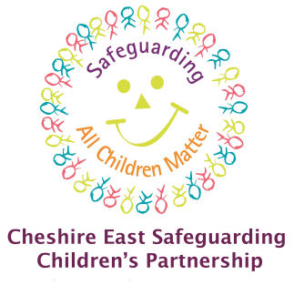

Cheshire East Children’s Safeguarding Partnerships
Quality Assurance Framework 2025 – 2028

 | PART 1 – Background and Context | Pages
1.1 | Introduction
1.2 | Local Context – Vision & Values
1.3 | Intended outcomes of the Cheshire East Safeguarding Partnership Quality Assurance Framework
1.4 | Governance
1.5 | Partnership Contributions
 | PART 2 – Methodology
2.1 | General Principles
 | PART 3 – The Quality Assurance Framework
3.1 | The Quality Assurance Framework Plan on a Page
3.2 | Component Parts of the Quality Assurance Framework
3.2.1 | Independent Scrutiny
3.2.2 | Inspections and Peer Review
3.2.3 | The Voice of Children, Young People, Families and Practitioners
3.2.4 | Rapid Reviews, Child Safeguarding Practice Reviews and Child Deaths
3.2.5 | Single-Agency Audits and Self-Assessment
3.2.6 | Multi-Agency Audits
3.2.7 | Multi-Agency Self-Assessment / JTAI Preparation
3.2.8 | Compliments and Complaints
3.2.9 | Annual Reports
3.2.10 | Insights and Learning from Relevant Strategic Forums
3.2.11 | Escalations
3.2.12 | Front Line Visits / Practice Observations
3.2.13 | Performance Framework (Data Sets)
4 | PART 4 - Learning Loops
4.1 | Visual Aid
4.2 | Summary Written Briefings
4.3 | Annual Safeguarding Partnership Conference
4.4 | Training and Development Programmes
4.5 | Policies and Procedures
5 | PART 5 - Information Sharing and Confidentiality
6 | PART 6 - Risk Register

 | APPENDICES
1 | Quality Assurance Timetable April 2025 – March 2028
2 | Data Sets – detailed reporting requirements
3 | Quality Assurance Sub-Group Terms of Reference
4 | Multi-Agency Audit Tool and Guidance
PART 1 – Background and Context

1.1 Introduction
The Children’s Safeguarding Partnership Quality Assurance Framework (QAF) defines the partnership approach to examining and evaluating the effectiveness of arrangements to safeguard children and young people in Cheshire East.
This framework enables partners to maintain a line of sight to the quality and effectiveness of safeguarding arrangements for children and supports the partnership to effectively discharge their statutory safeguarding responsibilities.
The framework is designed to support a culture of continuous learning at both operational and strategic levels, to enable intentional actions to improve local systems and in turn, to support improved outcomes for children and young people.
The QAF will support transparency and public accountability by directly hearing from the voices of children and young people, via the integration of independent scrutiny and by providing an evidence base to support the content of the published Annual Report.
1.2 Local Context – Vision and Values

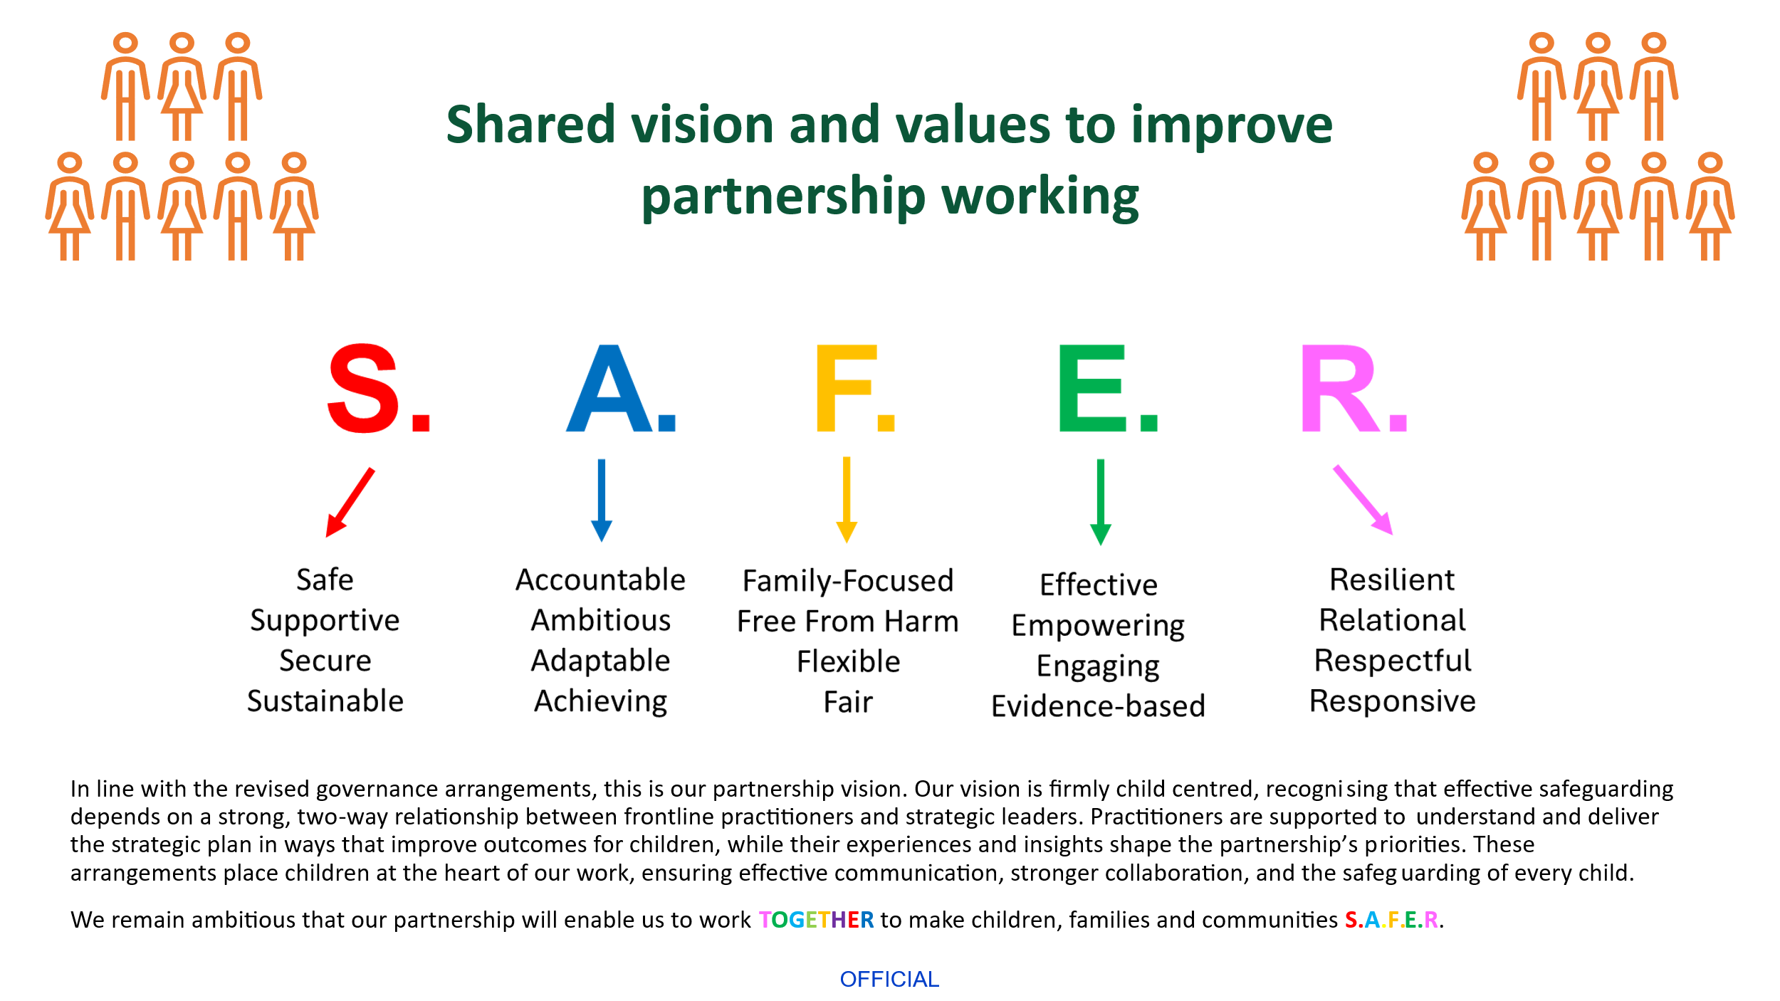
1.3 Intended outcomes of the Cheshire East Safeguarding Children’s Partnership Quality Assurance Framework
The Cheshire East Safeguarding Children’s Partnership (SCP) Quality Assurance Framework (QAF) outlines an approach to quality assurance and the analysis of performance information relating to Multi-Agency Safeguarding Arrangements (MASA) for children, both on a single and multi-agency basis and brings together a range of quantitative and qualitative information on the local arrangements for safeguarding children. The overarching aim is to enable the SCP to be as effective as possible in understanding the areas of strength and areas for improvement at both an operational and strategic level; to review and understand the impact of the local arrangements for safeguarding children and to identify new risks and emerging threats to respond early to prevent harm.
In accordance with Working Together to Safeguard Children (Department for Education, 2023; supplementary resources added 2025) and The Families First Partnership (FFP) Programme Guide 2025, the SCP QA becomes the mechanism through which the following activities and assurance are to be delivered:
- To enable local leaders and partners to understand what difference the organisations and practitioners providing services, are making for vulnerable children and families and “allows local partnerships to see the progress they are making towards the outcomes expected” (FFP Chapter 3).
- To enable local leaders and partners to have a good knowledge and understanding about the quality of local practice and its impact on children and families. (WT*, para 40).
- To identify, celebrate and extend examples of good practice, at both strategic and operational levels.
- To provide lead and delegated safeguarding partners, alongside the wider safeguarding partnership membership, with a clear line of sight to the quality of services designed to safeguard children and young people. (WT*, para 5 0 [1])
- To provide evidence which will support the lead and delegated safeguarding partners to identify and to monitor multi-agency priorities and procedures. (WT* para 50 [2], (WT* para 60 [1])
- To ensure that lead and delegated safeguarding partners have oversight of learning from independent scrutiny, serious incidents, child safeguarding practice reviews, and national reviews. (WT* para 50 [4], WT* para 60 [4])
- To ensure that delegated safeguarding partners are provided with insight to inform the provision of appropriate multi-agency safeguarding professional development and training. (WT*, para 60 [5].
- To ensure that a framework exists by which delegated safeguarding partners seek the voices of children and their families about their experiences of services and of co-designing services, to ensure that children from different communities can access the help and protection they need. (WT*, para 60 [6].
- To ensure that, alongside the voices of children and families, the knowledge of experienced practitioners and insights from data, provides a greater understanding of the areas of strength and /or improvement within arrangements and practice. (WT*, para 40)
- To collate, analyse and share data, broken down by protected characteristics, to facilitate more accurate and timely decision-making for children and families, and to understand outcomes for different communities of children. (WT*, para 40)
- To promote and embed a culture of continuous learning and development, which supports local services to become more reflective and implement changes to practice. (WT*, para 40)
- To inform the review of local priorities for the Children’s Safeguarding Partnerships.
- At a practice level, areas will need to be confident that quality oversight and assurance processes are in place. (FFP page 11).
- Operational decisions and the related responsibilities of different agencies will quality-assured for children who are the focus of section 47 enquiries and child protection plans. (FFP page 29)

1.4 Governance
For the SCP to effectively conduct its role and ensure the delivery of the principles in this framework, there is a need for all partners in Cheshire East to work together. On behalf of their partner agencies, members of the SCP Executive and the wider partnership commit to the following:
- to reflect and incorporate SCP priorities within their own planning process.
- to provide safeguarding data that evidences implementation of the SCP priorities and the fulfilment of statutory duties (incl. Section 11 and Section 175/157).
- to provide that data on a regular and timely basis through a named individual.
- to review the information and evidence gathered by the SCP and use it to challenge both their own agencies and partners and to effectively monitor the impact of that challenge.
- to use information held by the SCP to develop services and make improvements to existing services including at the early help and statutory level, using clear quality assurance processes to evidence the improvements made.
This will be conducted through the SCP governance structure.

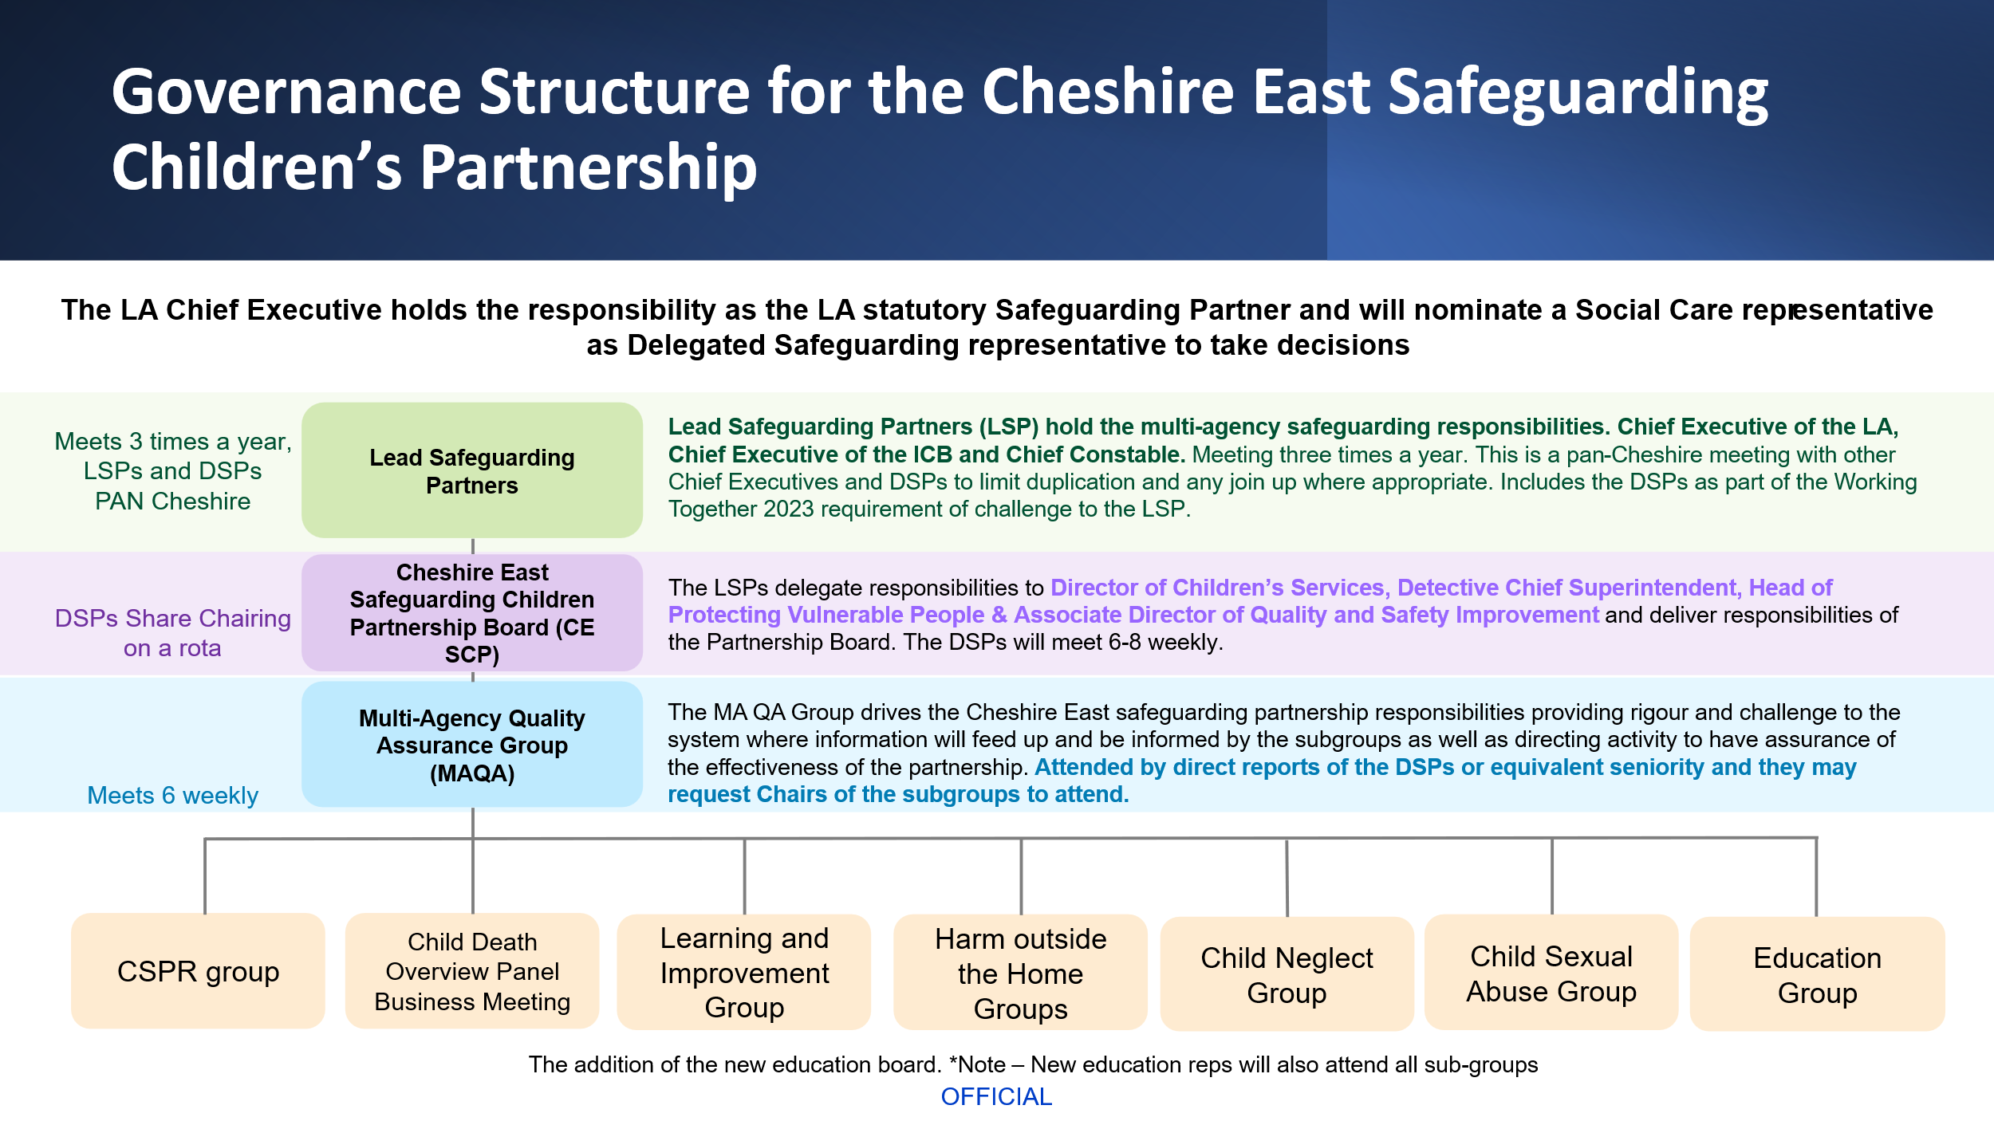

1.5 Partnership Contributions
All partners will be actively involved. This includes contributing to related activity and providing feedback on single agency quality assurance programmes. The SCP Multiagency Quality Assurance Group (MAQA) will oversee the framework and its application.
Delegated safeguarding leads and relevant agency leaders should ensure that nominated officers have sufficient capacity to achieve the aims of the framework.
Specifically, organisations should nominate lead officers to support the key functions of the QAF. Whilst this is likely to include the organisations quality assurance lead, other officers will also be required who are able to contribute to the framework requirements.
- Data reports and analysis
- Participation with children and families
- Audit
- Inspection preparation and oversight of plans resultant from inspection
- Engagement at Rapid Reviews and CSP Reviews
- Compliments and complaints
- Responding to escalations
- Managing activity relating to actions arising from partnership audit and quality assurance activities
- Communications
The focus of all activity will be on improved outcomes for Children and Young People (CYP), families, and communities. Activity will focus on:
- Practice - exploring practice-based issues that affect vulnerable groups.
- Organisational context - how organisations approach safeguarding.
It is important for the SCP to establish a consistent approach to the way in which all related activity is planned, supported, overseen, and monitored. The framework subsequently informs agencies of individual and collective responsibilities in actively contributing to all processes linked to multi-agency quality assurance and performance monitoring.

PART 2 Methodology

2.1 General Principles
Cheshire East Safeguarding Children Partnership (SCP) will undertake activity within a performance cycle, aligned with its priorities. A three yearly cycle of specific activities is timetabled to ensure all elements of the QAF are addressed. See Appendix 1 for the 2025 – 2028 period reporting timetable.
The QAF will be delivered through a child focused approach that prioritises the views and experience of children and families in telling us how they feel multi agency practice was effective.

The framework is supported by the function of independent scrutiny.
Annually, the delegated safeguarding partners should detail which elements of the QAF will be conducted by, or scrutinised by, the Independent Scrutineer/s. Capacity to respond to matters arising throughout the reporting year should be enabled alongside annually agreed areas of focus for independent scrutiny.

PART 3 – The Quality Assurance Framework

3.1 Quality Assurance Framework Plan on a Page
Inspections and Peer Reviews | Voices of children, families & practitioners | Child Safeguarding Practice Reviews & Rapid Reviews and Child Deaths | Data Set  (Performance Management) | Single-Agency Self-Assessment & Single Agency Audit Findings | Escalations
QUALITY ASSURANCE FRAMEWORK
2025 - 2028

Multi-Agency Audits | Compliments and Complaints | Annual Reports | Multi-Agency Self-Assessment e.g. JTAI inspection areas | Insights and learning from relevant strategic forums | Front line visits/Practice observations
↑ ↑ ↑ ↑ ↑ ↑ ↑ ↑ ↑ ↑ ↑ ↑

INDEPENDENT SCRUTINY

3.2 Component Parts of the Quality Assurance Framework

3.2.1 Independent Scrutiny

Independent scrutiny should drive continuous improvement and provide assurance that arrangements are working effectively for children, families, and practitioners. (WT*, para 90).
A programme of scrutiny activity will be commissioned by the safeguarding partners in partnership with the Independent Scrutineer.
The work of the Independent Scrutineer will be reported to the safeguarding leads group and the quality assurance sub-group quarterly.
The Independent Scrutineer will scrutinise the decisions made at rapid review panels on behalf of the statutory safeguarding partners.
The functions of independent scrutiny are defined in the statutory guidance, Working Together to Safeguard Children (Department for Education, 2023; supplementary resources added 2025)
- Provide safeguarding partners and relevant agencies with independent, rigorous, and effective support and challenge at both a strategic and operational level.
- Provide assurance to the whole system in judging the effectiveness of the multi-agency safeguarding arrangements through a range of scrutiny methods.
- Ensure that statutory duties are being fulfilled, quality assurance mechanisms are in place, and that local child safeguarding practice reviews and national reviews are analysed, with key learning areas identified and effectively implemented across the safeguarding system.
- Ensure that the voice of children and families is considered as part of scrutiny and that this is at the heart of arrangements through direct feedback, informing policy and practice.
- Be regarded as a ‘critical friend’ and provide opportunities for two-way discussion and reflection between frontline practitioners and leaders. This will encourage and enable strong, clear, strategic leadership.
- Provide independent advice when there are disagreements between agencies and safeguarding partners and facilitate escalation procedures.
- Evaluate and contribute to multi-agency safeguarding published arrangements and the annual report, alongside feeding into the wider accountability system.

3.2.2 Inspection and Peer Reviews
The quality assurance sub-group will receive exception reports pertaining to safeguarding inspections and peer reviews involving statutory and relevant partners. Highlight reports should evidence in brief the progress of actions plans, provide assurance that suitable single agency governance is in place to monitor those plans and should highlight best practice and risks arising where progress is delayed. These highlight reports should inform the QA sub-group risk register.
3.2.3 Voices of Children, Families and Practitioners
The quality assurance sub-group will be responsible for assuring the lead safeguarding partners that the workplans of the sub-group and priority workstream groups have addressed the requirement to consult with children, families, and practitioners. They will achieve this by reviewing action plans and receiving progress reports in relation to those plans.
All consultation should be summarised for the quality-assurance sub-group and the quarterly lead safeguarding partners meeting, to enable feedback to influence and inform strategic planning.
Where consultation and participation raise issues pertaining to operational matters, these should be fed back to agency operational leads to act upon.
There is an expectation that partner agencies will have internal processes for consultation and participation. Where these raise issues pertaining to the safeguarding of children, findings should be shared with the quality assurance sub-group and shared accordingly to the risk register.
Audit processes should integrate opportunities for feedback from children, families and practitioners and form part of all audit evaluations.
3.2.4 Rapid Reviews, Child Safeguarding Practice Reviews and Child Deaths
Child Safeguarding Practice Reviews and Rapid Reviews
A child safeguarding practice review (CSPR) will be undertaken when a child or young person under 18 dies or is seriously injured and abuse and/or neglect is suspected or known to be a factor, and there is concern that partner agencies could have worked more effectively to protect them. These reviews are a statutory duty under Working Together to Safeguard Children (Department for Education, 2023; supplementary resources added 2025) and the outcomes and lessons learned from CSPRs should be published.
The Cheshire East CSPR guidance includes details of the referral process, methodologies, and templates for completing the CSPR process..
The Cheshire East CSPR panel considers all serious incident notifications made to the National Child Safeguarding Practice Review Panel. If undertaken, a rapid review will result in a recommendation about whether a case meets the criteria for a CSPR.
The Independent Scrutineer will scrutinise the decision made at the rapid review on behalf of the statutory safeguarding partners.
Learning from Rapid Reviews and CSPR’s and progress reports on action plans will be led by the CSPR Panel and shared with the quality assurance sub-group. Delays with progressing actions from these plans should inform the risk register.
Child Death Overview Panel
The Cheshire East Child Death Overview Panel (CDOP) will review the deaths of all children in the local area to determine if the death was preventable and whether there are any modifiable factors to prevent similar deaths occurring in the future.
Learning from the child death process and progress reports on action plans will be shared with the quality assurance sub-group bi-annually.
3.2.5 Single Agency Audits and Self-Assessment
All statutory partners should have mechanisms in place to assess the quality of their practice and service provision.
As part of the Children’s Safeguarding Partnership annual planning and priority setting, the quality assurance sub-group should review statutory partner’s self-assessments to ensure key areas of risk are identified and addressed in the annual work plan.
Any areas of good practice which could be extended should be shared with the quality assurance sub-group, so consideration can be given to sharing the practice more widely.
Any areas of single agency audits which persistently indicate concerns for the safeguarding of children should be escalated to the quality assurance sub-group who will consider any actions the partnership need to take to support and monitor the improvements required.
Partner agencies will also be required to participate in self-assessments as required by the Safeguarding Partnership which include but will not be limited to,
- S11 Audit (bi-annually) – compliance with duties to cooperate under the 2004 Children Act
- S175/157 (bi-annually)- Audit of Safeguarding Arrangements in Schools and Colleges
- Self-Assessment of agency work in relation to the JTIA area of focus.
3.2.6 Multi-Agency Audits
An annual cycle of multi-agency audits will be agreed by the quality assurance sub-group.
The audits should reflect areas of practice which have been identified for improvement (x3 audit cycles per year).
Multi-agency audits will also be completed to support the annual multi-agency JTAI self-assessment (x1 audit cycle per year).
Contact audits will be conducted monthly. The audit programme will be agreed by MAQA.
There will be an annual audit of strategy (x1 audit cycle per year) and child protection conferences (x1 audit cycle per year), which are core child protection activity.
S11 audits will be completed bi-annually, on alternate years and S175 will be annually.
The above represents muti-agency audit activity for 10 months per year, allowing for a break in August and December.
The methodology for each audit will specify what is required of agency representatives. For every audit.
- Agency audit findings should be approved by a senior manager.
- Immediate concerns about the safeguarding of children will be escalated for action.
- Single agency learning identified will be progressed by the agency strategic lead.
- The audits will consider how feedback from children, families and practitioners will inform the audit.
All completed audits will conclude with an action plan which will detail how progress will be monitored and how the impact on outcomes for children and young people will be analysed.
Audit action plans will be monitored by the quality assurance sub-group.
The audit lead will provide a one page ‘learning summary’ from the audit which will be shared across the partnership.
Examples of audit templates are provided at Appendix 3 and will be further developed.
3.2.7 Multi-Agency Self-Assessment / JTAI Preparation
Annually, the quality assurance sub-group will agree to assess the safeguarding partners against one of the JTAI Ofsted Inspection areas. This will involve identified agencies completing a self-assessment which will be brought together in an analytic multi-agency assessment report. The JTAI preparation will also use multi-agency audits to inform partners understanding of the quality of work in a JTAI focussed area of work.
The completed multi-agency self-assessment should result in an improvement plan which will be monitored by the quality assurance sub-group.

3.2.8 Compliments and Complaints
All agencies should have processes in place to identify compliments and to respond to complaints. At each quarterly meeting of the quality assurance sub-group, statutory partners and relevant agencies will be asked to produce a summary of any emerging themes for their complaints data which would have implications for the effectiveness of local multi-agency safeguarding children’s arrangements.
3.2.9 Annual Reports
The following single agency annual reports are also directly related to multi-agency safeguarding arrangements and should be presented annually to the quality assurance sub-group.
- Local Authority Designated Officer Annual Report (LADO)
- Independent Child Protection Conference Chairs annual report
Action plans arising from these annual reports should be provided to the quality assurance sub-group twice per year.
3.2.10 Insights and learning from relevant strategic forums.
There are interdependencies between local arrangements and other strategic partnership work happening locally to support children and families (WT*, para 44)
- Education board
- Safeguarding Adults Board
- Early Help board
- Families First Board
- Health and Wellbeing Board
- Cheshire East Safeguarding Adults Board
- Channel Panel
- Improvement Boards
- Safer Cheshire East Partnership
- MAPPA Strategic Management Board
- Local Drug and Alcohol Partnerships
- Cheshire East Domestic Abuse and Sexual Violence Partnership
- Corporate Parenting Board
- Youth Justice Service Management Board
The lead safeguarding partners should identify members in common from the following partnership arrangements and require the named children’s safeguarding partnership linked officer to present the partnership forums annual report to the quality assurance sub-group, with a focus on multi-agency safeguarding arrangements for children.
Any safeguarding children’s issues which arise through the course of the year, should be shared with the quality assurance subgroup via the linked officer to ensure that there is a coherent and joined up local analysis of linked safeguarding matters.
Persistent matters of concern should be included on the risk register.
2.3.11 Escalations
The SCP has adopted the Pan-Cheshire Procedure for resolution of professional disagreement relating to safeguarding and child protection. The SCP Business Support Team maintain a tracker of escalations and the Business Manager will report quarterly basis to MAQA. This meeting scrutinises these.
2.3.12 Front Line Visits / Practice Observations
The Frontline visits and Practice Observations are undertaken to provide a line of sight between the partnerships and Frontline practice. These are done in partnership with the Safeguarding Adults Board.
A programme of dates, venues for visits and questions is agreed between the SCP and SAB. After the visits have been completed a joint report is provided to the SAB and SCPs MAQA for scrutiny.

2.3.13 Performance Framework (Data Sets)
The data set return represents a quarterly performance framework to provide scrutiny and assurance about core multi-agency and single agency performance in relation to services received by children in Cheshire East.
Of critical importance is the analysis of the data being presented alongside the data sets. This analysis will consider trends over time and improving and deteriorating performance. The quality assurance sub-group will seek to understand barriers to performance and identify actions required to improve performance.
The quality assurance sub-group receiving the information will produce an exception report for the designated leads group, identifying areas where they need to act to support learning and strategic and practice improvements.
Data provided by all agencies should be in relation to the Cheshire East Local Authority area geographical footprint and not aggregated. This is to ensure that scrutiny of and learning specifically in relation to local arrangements can be accurately identified.
Where available, the most recent statistical neighbour and national data should be provided alongside local data reporting.
A summary analysis of a full years reporting data should be prepared for the Annual Report and be used to inform the following year’s priority setting.
The data set has eight core areas which allow for flexibility over time dependent upon changes to focussed areas for assurance and Safeguarding Partnership priorities.

PART 4 Learning Loops

4.1 Learning Loops Visual Aid
The PQF (diagram below) shows how the impact will be understood, reviewed, and developed.

Further details are provided about required routes for the dissemination of learning.
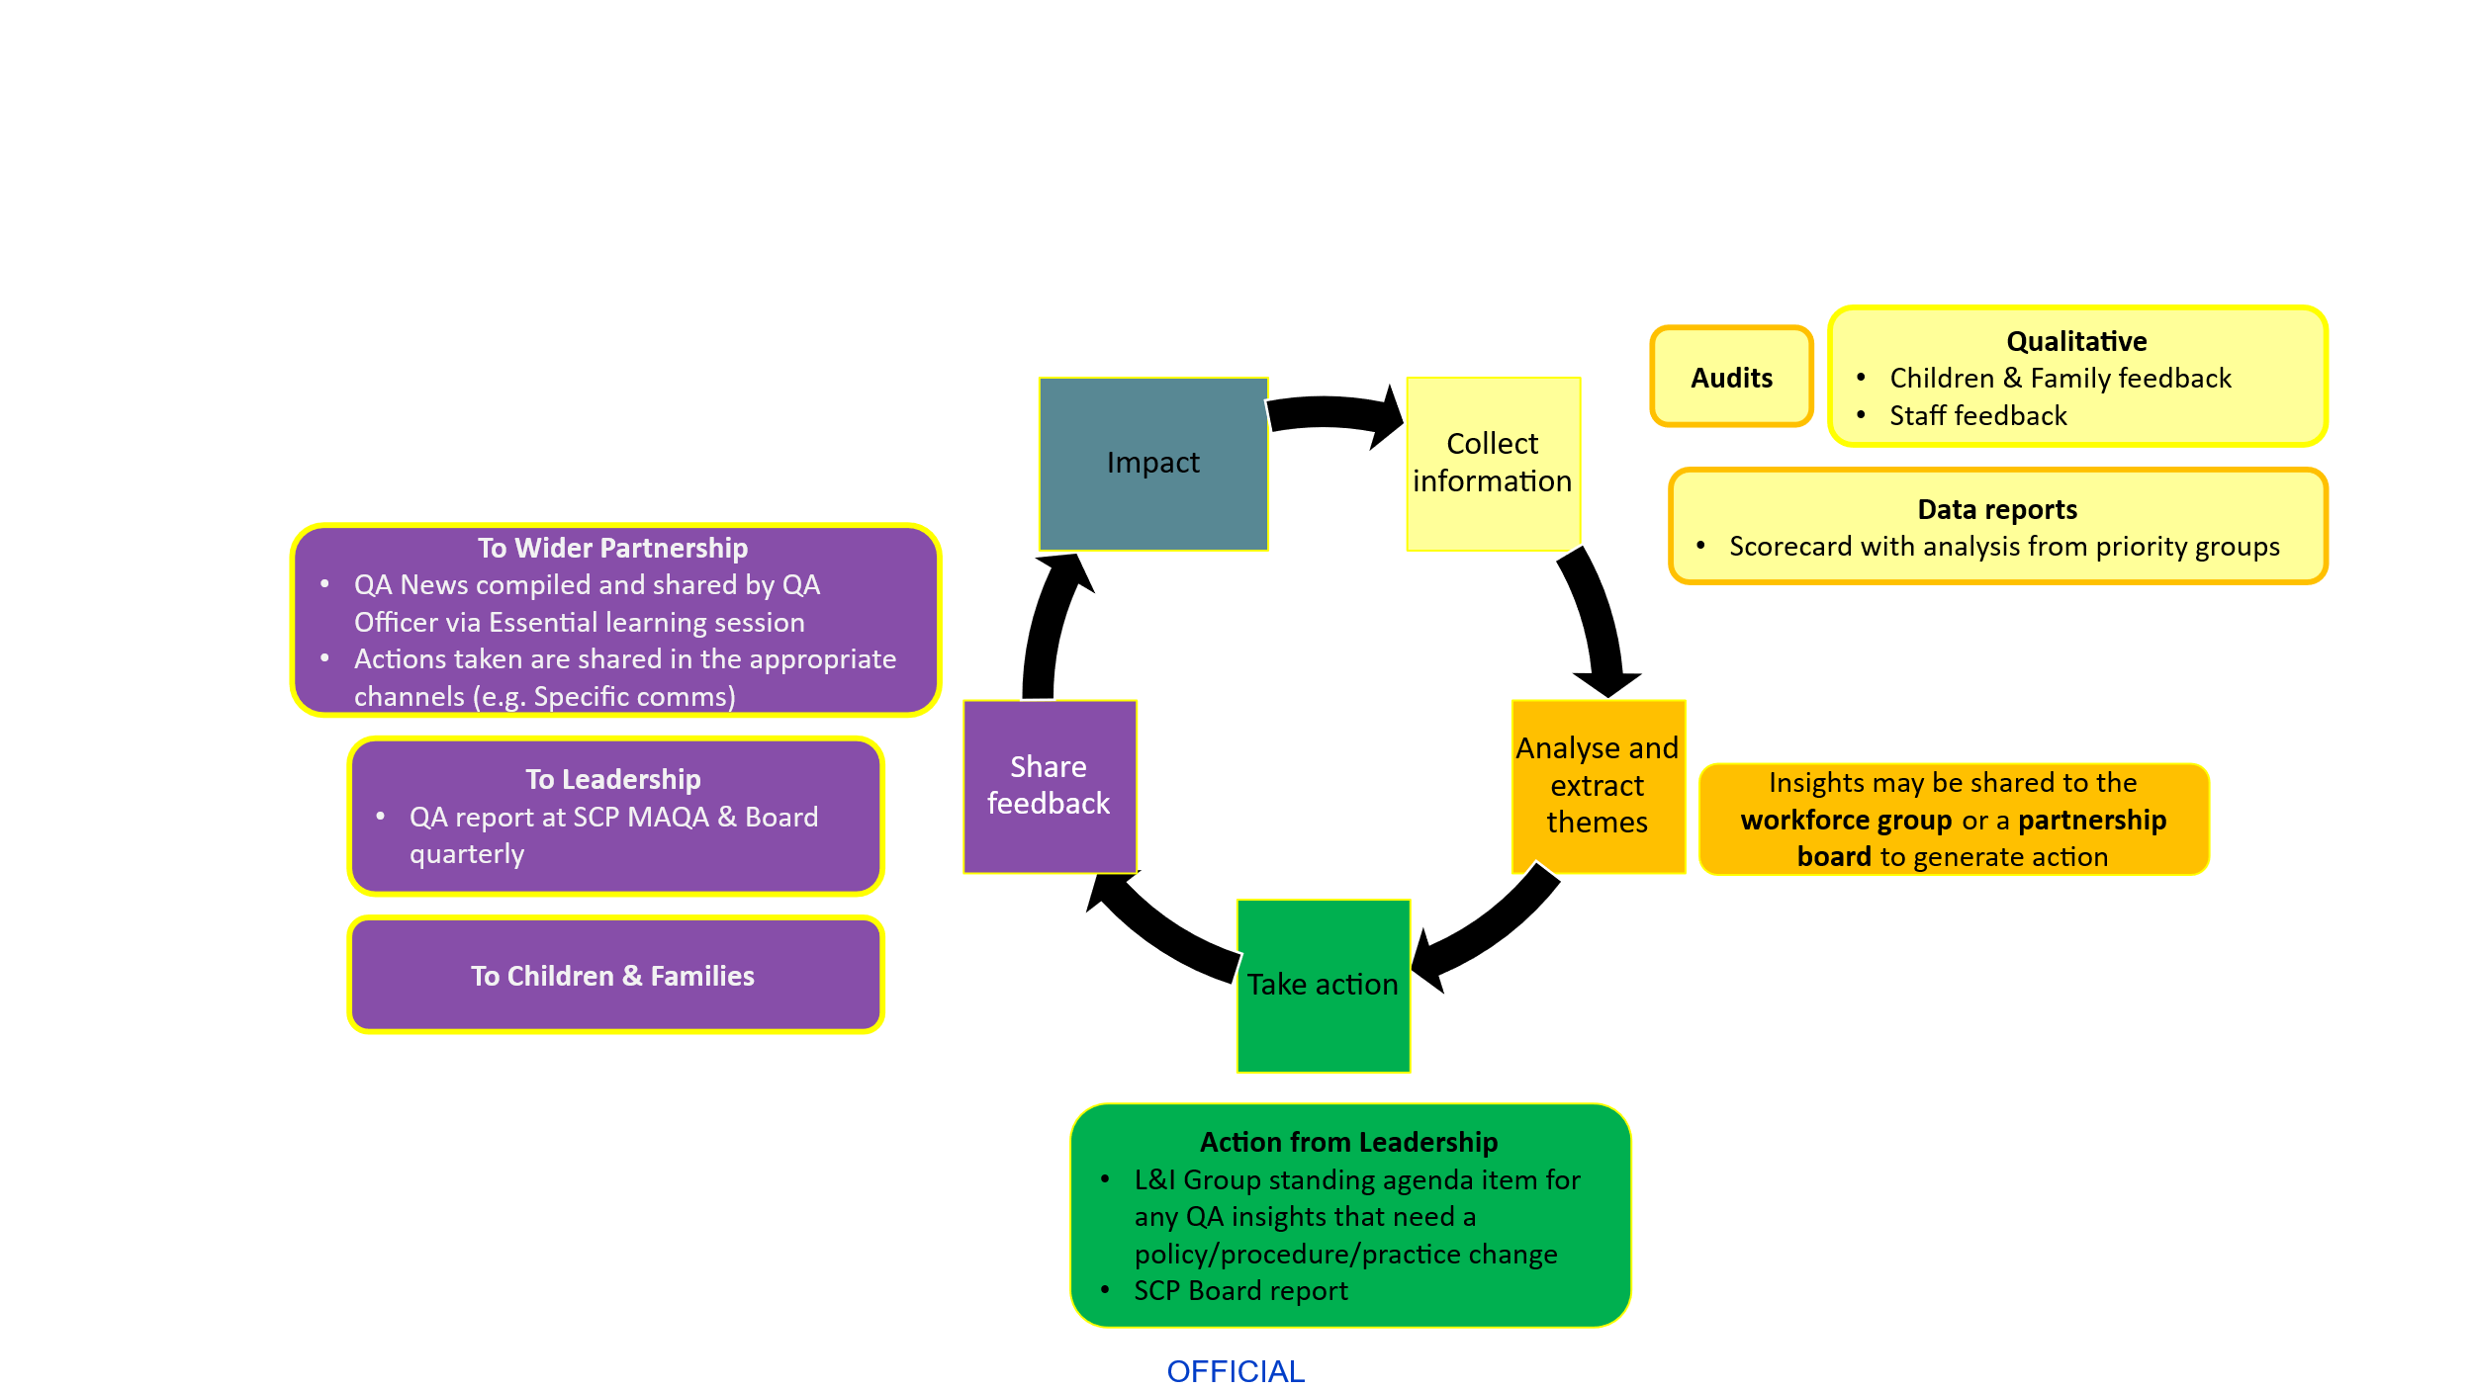

4.2 Summary Written Briefings
The QAF should be used to inform leaders, managers, and practitioners about the effectiveness of local services to support and safeguard children. It should analyse available sources of information to make SMART recommendations for improved strategic arrangements and improved practice.
The output of every QAF activity should be summarised into a short briefing which identifies key issues at five levels and recommends future actions.
- Strategic learning
- Management learning
- Practice learning
- Child and family’s voices
- Issues of equity and inclusion
- SMART Actions
All learning summaries should be shared with the learning and development sub-group, who will lead on dissemination and feedback loops.
- All briefings should be shared with the lead and delegated safeguarding partners at the quarterly safeguarding partners group. These briefings should highlight strategic issues.
- Joint manager and practitioner practice learning briefings should be shared with statutory partner representatives and representatives from relevant partners whose role will be to support dissemination within their own sector / agency. Partner agencies should provide assurance that they have pro-actively supported the dissemination of learning.
Learning is most effective when targeted and consideration should be given to who are appropriate target audiences and how briefings will be disseminated.
The quality assurance sub-group should monitor the impact of the dissemination of learning through the ongoing cycle of quality assurance activity.
4.3 Annual Safeguarding Partnership Conference
Core learning derived from annual quality assurance activity will be shared at the Children’s Safeguarding Partnership Annual Conference. This annual conference will also provide the partnership with the opportunity to hear directly from the children’s workforce.
4.4 Training and Development Programmes
Working Together to Safeguard Children (Department for Education, 2023; supplementary resources added 2025) identifies ‘the provision of multi-agency safeguarding professional development and training’s s one of the joint functions of the delegated safeguarding partners.
The quality assurance group will share all summary written briefings about their activity to the chair of the Learning and Improvement sub-group, to enable them to ensure training is delivered which is fully reflective of local learning and development needs.
4.5 Policies and Procedures
Working Together to Safeguard Children (Department for Education, 2023; supplementary resources added 2025) identifies ‘the delivery and monitoring of multi-agency priorities and procedures to protect and safeguard children in the local area…’ as one of the joint functions of the delegated safeguarding partners.
The quality assurance group will share all summary written briefings about their activity to the chair of the learning and development sub-group, to enable them to ensure that policies and procedures are developed which are fully reflective of local learning and cognisant of the needs to the local population(s).
Part 5 Information Sharing and Confidentiality
As part of the quality assurance process no personal information will be made public and no individuals will be personally identifiable. All staff who are part of SCP quality assurance activity will take the necessarily steps to safeguard personal and sensitive information.
Local information sharing protocols are published here which includes principles and expectations specific to Data Protection, Information Sharing and Confidentiality.
Part 6 Risk Register
The quality assurance sub-group chair will maintain a risk register detailing areas of persistent concern identified by quality assurance activity, or areas where progress against action plans is delayed. The risk register will be provided to the lead safeguarding partners for their oversight and scrutiny quarterly.

APPENDICES
APPENDIX 1 - Quality Assurance Timetable April 2026 – March 2029
Framework Element and Forum for Monitoring | Lead for Analysis Report | Evidence Source | Reporting Frequency
 |  |  | Quarterly | Annual | Bi-Annual | 3 Yearly
Inspections and Peer Reviews  Action Plan Monitoring via QA Sub-Group | Quality Assurance Lead for agency inspected | Ofsted, CQC, His Majesty’s Inspectorate of Constabulary and Fire and Rescue Services, HMI Prisons and Probation Inspection Reports  Focus should be the outcomes from any Safeguarding Inspections / Safeguarding elements of inspections.
 | Planned Peer Review | Report and Action Plan from Peer Review
Voices of children, families  Task and Finish Groups to Plan and Implement Activity  Action Plan Monitoring via QA Sub-Group | HoS Childrens Safeguarding | Parents with children subject to a CP Plan feedback form
 | Priority Group Chairs to ensure consultation is included in priority work areas | Feedback linked to each priority areas. Consultation should be arranged for all priority areas to seek feedback and enable co-production.
 | Single agency leads for participation
Voices of practitioners  Priority Groups to Plan and Implement Activity  Action Plan Monitoring via L&I | Principal Social Worker & QA Officer SCP
Child Safeguarding Practice Reviews and Rapid Reviews  CSPR Sub-Group report for outstanding actions reported MAQA | Commissioned Independent Author  Business Manager | Reports and findings with linked SMART Action plans
Data Set  Reporting should lead to targeted actions which are monitored, to increase best practice and address areas for improvement. | Produced by Data Analyst Leads, collated the SCP Business Team. Analysis by agency Leads for reporting to MAQA. | Data Set Framework
Single-Agency Self-Assessment and summary report of Audit Findings | Allocated Lead from all Statutory Partners | Children’s Services Self-Assessment  Partner Agencies to identify relevant agency material |  | S175 | S11
Escalation | SCP Business Manager
Multi-Agency Audits | SCP QA Officer | SCP Multiagency audit programme
Multi-Agency Audits | Front Door Service Manager | Contact at the front door audits
Multi-Agency Audits | Agency rep | Single agency audits
Multi-Agency Audits | HoS Safeguarding | Quality assurance of Child Protection conferences
Multi-Agency Audits | HoS Safeguarding | LADO audit
Compliments and Complaints | Agencies Complaints Manager | Summary Analysis Relevant Annual Compliments and Complaints Reports e.g. Children’s Social Care Annual Report – Statutory Complaints
Annual Reports | To be presented by relevant HoS | Private Fostering  LADO  CP Conference Chairs  Partner Agencies to bring relevant Annual Reports  CDOP
Multi-Agency Self-Assessment JTAI inspection areas | SCP Business Team | Partnership Self-Assessment for JTAI Area
Insights and learning from relevant strategic forums | A member of the relevant forum should be formally identified as a link officer to the SG Partnership and provide annual summary reports about linked key SG issues. | Education board  Safeguarding Adults Board  Early Help board  Families First Board  Health and Wellbeing Board  Cheshire East Safeguarding Adults Board  Channel Panel  Improvement Boards  Safer Cheshire East Partnership  MAPPA Strategic Management Board  Local Drug and Alcohol Partnerships  Cheshire East Domestic Abuse and Sexual Violence Partnership  Corporate Parenting Board  Youth Justice Service Management Board
Annual Report | SCP Business Manager | Required by Working Together to Safeguard Children (Department for Education, 2023; supplementary resources added 2025). |  | Annual
Front line visits/Practice Observations | SAB/SCP Business Teams | Visits to interview/observe practitioners by multi-agency partners |  | Annual
Independent scrutiny | Independent scrutineer | Independent, rigorous, and effective support and challenge at both a strategic and operational level.  Assurance to the entire system in judging the effectiveness of the multi-agency safeguarding arrangements through a range of scrutiny methods.  Ensure that statutory duties are being fulfilled, quality assurance mechanisms are in place, and that local child safeguarding practice reviews and national reviews are analysed, with key learning areas identified and effectively implemented across the safeguarding system.  Ensure that the voice of children and families is considered as part of scrutiny and that this is at the heart of arrangements through direct feedback, informing policy and practice.  ‘Critical friend’ and provide opportunities for two-way discussion and reflection between frontline practitioners and leaders.  Provision of independent advice when there are disagreements between agencies and safeguarding partners and facilitate escalation procedures.  Evaluation and contribution to multi-agency safeguarding published arrangements and the annual report, alongside feeding into the wider accountability system.

APPENDIX 2

Performance Framework – (Data Sets)
1  Population Level Child Safety | Child Homicides  Child deaths due to assault and undetermined intent  Child suicides  Sudden and unexpected deaths in infancy  Infant mortality rate  Child poverty rate
2  Abuse and Neglect | Contacts, referrals, and step-up from early help  Strategy Discussions  Section 47 Enquiries  Child Protection Plans  Children in care  Sexual offences recorded  Child cruelty and neglect offences  Serious incident notifications
3  Child Vulnerability Indicators | CSC Populations (Open to CSC number per 10,000 with regional, national, and statistical neighbour breakdown where available).  Early-help plans in the partnership.  Child Exploitation  Children Missing from Care and Home  Attendance Vulnerabilities  Electively Home Educated Children (show by gender for)  Reasons for fixed term exclusions  CAMHS - open and waiting.  Tier 4 bed provision  Domestic Abuse  Parental mental ill-health  Parental drug and alcohol use
4  Custody, Youth Justice, and Serious Violence | Custody and Arrests  Serious Youth Violence  National Referral Mechanism and Modern-Day Slavery
5  Children’s Safeguarding Partnership Priority Areas | 
6  Focussed areas for assurance, resultant for learning from Child Safeguarding Practice Reviews and multi-agency audits | To be defined according to the recommendations from CSPR’s.
7  Contextual Indicators | Workforce Sufficiency of Statutory Partners  Caseload Data – qualified social workers  Local Authority spend on children’s services
8  Partnership Enablers as identified in the DfE’s Children’s Social Care National Framework | To be added when Published by the DfE)

APPENDIX 3 - Quality Assurance Sub-Group Terms of Reference
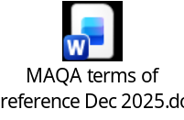
APPENDIX 4 - Multi-Agency Audit Tool and Guidance


Contact Audits

